Smart Feedback Collection and Analysis System

TCS iON Industry Project
Complete Project Documentation

Prepared by: Akula Sandeep Kumar
Department of Computer Science and Engineering
JNTUH University College of Engineering, Manthani

Executive Summary
The Smart Feedback Collection and Analysis System is a full-stack web application designed to modernize and automate the process of gathering, managing, and analysing user feedback in organizations. The system integrates Artificial Intelligence (AI) and Natural Language Processing (NLP) techniques using the TextBlob library to automatically determine the sentiment of feedback as Positive, Negative, or Neutral.
Developed using the Flask framework, the application provides a seamless user experience through role-based access control for Guest Users, Registered Users, and Administrators. It enables users to submit feedback easily while allowing administrators to analyse collective insights through interactive and visually appealing charts powered by Chart.js.
Security is implemented through robust mechanisms including password hashing, secure session management, and time-limited password reset tokens. The system also supports email notifications, data visualization, and feedback categorization, ensuring transparency and accountability across the feedback process.
By combining data analytics, visualization, and AI-driven sentiment analysis, this project provides a scalable and reliable platform for improving user satisfaction and organizational decision-making. The Smart Feedback Collection and Analysis System serve as a step towards transforming traditional feedback collection into an intelligent, automated, and insightful digital process.

Table of Contents
Smart Feedback Collection and Analysis System i
Executive Summary ii
Chapter 1 - Introduction 1
1.1. Background 1
1.2. Problem Statement 1
1.3. Purpose of the Project 2
1.4. Objectives 2
1.5. Scope of the Project 2
1.6. Key Features 3
1.7. Technology Stack 3
1.8. System Modules 4
1.9. Expected Outcomes 4
1.10. Summary 4
Chapter 2 - System Architecture & Design 5
2.1. Introduction 5
2.2. Architectural Overview 5
2.3. System Architecture Diagram 7
2.4. Workflow Description 7
2.5. Database Design 9
2.5.1. Users Table 9
2.5.2. Feedback table 9
2.6. Component Design 10
2.7. Security Architecture 11
2.8. Design Principles 11
2.9. System Advantages 11
2.10. Summary 12
Chapter 3 - API Documentation 13
3.1. Introduction 13
3.2. Base Configuration 13
3.3. Authentication Mechanism 13
3.4. Public Routes 14
3.4.1. Home Page 14
3.4.2. Guest Feedback Submission 14
3.4.3. User Registration 15
3.4.4. User Login 15
3.4.5. Password Reset Workflow 16
3.5. User Routes (Protected) 16
3.5.1. Submit Feedback 16
3.5.2. User Dashboard 17
3.6. Administrative Routes 17
3.6.1. Admin Dashboard 17
3.6.2. Delete Feedback 17
3.7. Rate Limiting 18
3.7.1. Sentiment Statistics 18
3.7.2. Chart Data 18
3.8. Error Handling 18
3.9. Workflow Summary 19
3.10. Summary 19
Chapter 4 - Deployment and Configuration 20
4.1. Introduction 20
4.2. Deployment Environment 20
4.2.1. Key Features of Render Deployment 20
4.3. Pre-Deployment Requirements 20
4.4. Environment Variable Configuration 21
4.5. Deployment Procedure on Render 21
4.6. Post-Deployment Testing 22
4.6.1. Functional Tests 22
4.6.2. Mail Functionality 23
4.7. Security and Maintenance 23
4.8. Scalability and Future Deployment Options 23
4.9. Summary 24
Chapter 5 - Testing and Validation 25
5.1. Introduction 25
5.2. Testing Objectives 25
5.3. Types of Testing Performed 25
5.4. Testing Environment 26
5.5. Test Case Design 26
5.6. Validation Metrics 26
5.7. Testing Results Summary 27
5.8. Validation Conclusion 27
5.9. Supporting Test Documentation 27
5.10. Summary 28
Chapter 6 - Results and Discussion 29
6.1. Introduction 29
6.2. Overview of Results 29
6.3. Functional Results 29
6.3.1. Authentication and Access Control 29
6.3.2. Feedback Management 30
6.3.3. Sentiment Analysis Output 30
6.3.4. Visualization and Analytics 31
6.3.5. Mail Integration 31
6.4. Quantitative System Performance 31
6.5. Qualitative Evaluation 32
6.5.1. Usability 32
6.5.2. Security 32
6.5.3. Scalability 32
6.6. Discussion of Results 32
6.7. Comparative Evaluation 33
6.8. Key Achievements 33
6.9. Summary 33
Chapter 7 - Conclusion and Future Scope 35
7.1. Introduction 35
7.2. Project Summary 35
7.3. Major Outcomes and Achievements 35
7.4. Conclusion 36
7.5. Limitations 37
7.6. Future Scope / Enhancements 37
7.7. Summary 38
Chapter 8 - References and Appendices 39
8.1. Introduction 39
8.2. References 39
8.2.1. Web Resources 39
8.2.2. Tools and Platforms 40
8.3. Appendices 40
8.3.1. Appendix A – Database Schema 40
8.3.2. Appendix B – Major API Endpoints 41
8.3.3. Appendix C – Environment Variable Configuration 41
8.3.4. Appendix D – Test Documentation Summary 42
8.3.5. Appendix E – Screenshots and Output Samples 42
8.3.6. Summary 46

Introduction

Background
In today’s digital ecosystem, feedback is the cornerstone of organizational improvement. Whether in academic institutions, businesses, or customer-oriented services, understanding user experience is essential for refining products and processes. However, the conventional methods of gathering feedback such as manual surveys, static forms, and offline responses are inefficient, time-consuming, and prone to data loss.
The Smart Feedback Collection and Analysis System was conceived to address these limitations by introducing automation, sentiment intelligence, and real-time analytics into the feedback process. By leveraging the capabilities of Artificial Intelligence (AI) and Natural Language Processing (NLP), the system transforms raw textual feedback into actionable insights that help organizations make informed decisions quickly and effectively.

Problem Statement
Most organizations collect large volumes of feedback but fail to extract meaningful patterns or sentiments from them due to manual evaluation. This leads to:
- Delayed responses to user issues,
- Inefficient decision-making, and
- Lack of a data-driven feedback culture.
The problem thus lies not in feedback scarcity but in the absence of intelligent feedback processing and visualization tools. There is a need for a secure, automated, and centralized platform that can collect, analyse, and visualize feedback effectively while maintaining data privacy and integrity.

Purpose of the Project
The primary goal of this project is to design and develop a web-based Smart Feedback Collection and Analysis System that automates every stage of the feedback cycle: from data collection and sentiment classification to visualization & reporting.
It provides a role-based platform where:
- Guests can submit feedback without registration,
- Registered Users can view their submission history, and
- Administrators can monitor system-wide trends through analytical dashboards.
By doing so, the project aims to make organizational feedback management transparent, efficient, and intelligence-driven.

Objectives
      - To develop a scalable feedback platform that supports both guest and authenticated submissions.
      - To integrate NLP-based sentiment analysis to automatically classify textual feedback as Positive, Negative, or Neutral.
      - To provide data visualization dashboards that summarize key statistics such as category-wise distribution, ratings, and sentiment trends.
      - To ensure data security using encryption, secure sessions, and proper authentication mechanisms.
      - To support easy deployment across environments like Replit, Heroku, and AWS for portability and real-world usability.

Scope of the Project
The Smart Feedback System is designed to serve multiple sectors — educational institutions, e-commerce platforms, service providers, and public organizations.
Its modular architecture allows:
- Feedback submission from diverse users,
- Automatic sentiment computation,
- Administrator review through interactive dashboards, and
- Scalable database management for long-term analytics.
While the current implementation focuses on text-based feedback and sentiment analysis, the architecture supports future integration with voice or multimedia feedback modules.

Key Features
      - AI-Driven Sentiment Analysis using TextBlob for quick and accurate polarity detection.
      - Interactive Data Visualization with Chart.js for real-time graphical representation.
      - Role-Based Access Control for Guests, Users, and Admins.
      - Secure Authentication and Session Management employing PBKDF2-SHA256 hashing.
      - Feedback Categorization across multiple domains such as Product, Service, Support, and Website.
      - Comprehensive Admin Dashboard for data monitoring, exporting, and insight generation.
      - Modular Deployment Support for local and cloud-based hosting.

Technology Stack
Layer | Technologies Used
Frontend | HTML5, CSS3, JavaScript, Chart.js
Backend | Flask (Python)
Database | SQLite3 / MySQL
AI / NLP | TextBlob
Deployment | Replit, Heroku, AWS
Security | PBKDF2-SHA256 Hashing, Flask-Session Management

System Modules
        - User Module – Handles user authentication, feedback submission, and data validation.
        - Admin Module – Provides analytics, dashboard insights, and system configuration.
        - Feedback Processing Module – Performs NLP-based sentiment analysis and categorization.
        - Visualization Module – Generates sentiment distribution, category-wise charts, and rating histograms.
        - Security Module – Implements encrypted sessions, token-based resets, and access control.

Expected Outcomes
- Improved organizational responsiveness to user feedback.
- Reduced manual analysis time through AI automation.
- Data-driven visualization for strategic decisions.
- Scalable and deployable solution adaptable across industries.

Summary
This chapter introduced the concept, motivation, and objectives behind the Smart Feedback Collection and Analysis System. The chapter established the problem context, identified system goals, and outlined the technologies used to achieve them.
The forthcoming chapters will discuss the system architecture, API design, deployment process, and development workflow in detail, culminating in a comprehensive understanding of how the project delivers intelligent feedback management.

System Architecture & Design

Introduction
A well-structured system architecture ensures that every software component interacts seamlessly, securely, and efficiently. The Smart Feedback Collection and Analysis System follow a modular architecture that promotes scalability, maintainability, and flexibility.
The design integrates frontend presentation, backend logic, database management, and machine-learning-based sentiment analysis into a cohesive, service-oriented workflow.
The High-Fidelity Design Resource: Link
Note: The design has page flows and interactive components and elements. To experience the page flows, click present after you open the link else you can click link here - link

Architectural Overview
The system adopts a multi-tier architecture, clearly separating client interaction, business logic, and data storage.
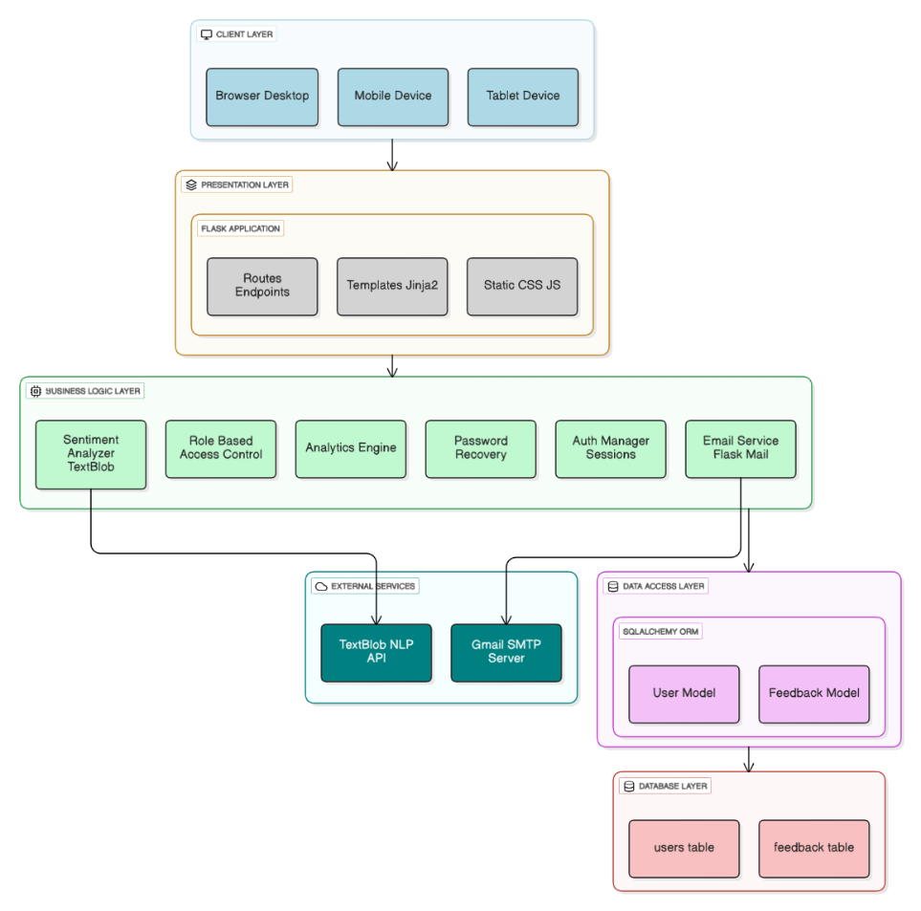
Figure 2.1 – System Architecture Diagram of Smart Feedback System
Layers Description:
- Client Layer
- Users can access the system via browser, mobile, or tablet.
- Provides interfaces for feedback submission, login, registration, and visualization.
- Communicates with the Flask server using HTTP requests.
- Presentation Layer
- Acts as the front controller managing user interaction and server responses.
- Contains Routes & Endpoints, Jinja2 Templates, and Static CSS/JS files.
- Renders dynamic pages for users, guests, and admins.
- Business Logic Layer
Implements the core operations of the system:
- Sentiment Analyzer (TextBlob) – determines sentiment polarity of feedback.
- Role-Based Access Control – separates privileges for Admin, Registered User, and Guest.
- Analytics Engine – generates statistical insights and sentiment charts.
- Password Recovery & Auth Manager – handles secure sessions and account recovery.
- Email Service (Flask Mail) – delivers password reset and notification emails.
- External Services
- TextBlob NLP API – used for natural-language sentiment computation.
- Gmail SMTP Server – handles outgoing password-reset and notification emails.
- Data Access Layer
  - Defines and manages database models (UserModel, FeedbackModel).
  - Converts Python objects into SQL records for database operations.
- Database Layer
- Physically stores data in relational tables (users, feedback).
- Ensures referential integrity, indexing, and timestamped records.
This multi-layer design enforces clear separation of concerns—allowing independent modification or scaling of UI, logic, or storage without affecting other layers.

System Architecture Diagram
The logical flow of the system can be summarized as follows:
        - User Interface: Provides forms for feedback input and dashboards for analytics.
        - Flask Application: Acts as the central controller connecting the UI, sentiment model, and database.
        - NLP Engine: Processes the text feedback and assigns a sentiment polarity score.
        - Database: Stores processed data for long-term analysis.
        - Visualization Module: Generates charts (pie, bar, line) for sentiment distribution, category analysis, and ratings over time.

Workflow Description
The workflow describes how feedback travels through the system depending on the user role.
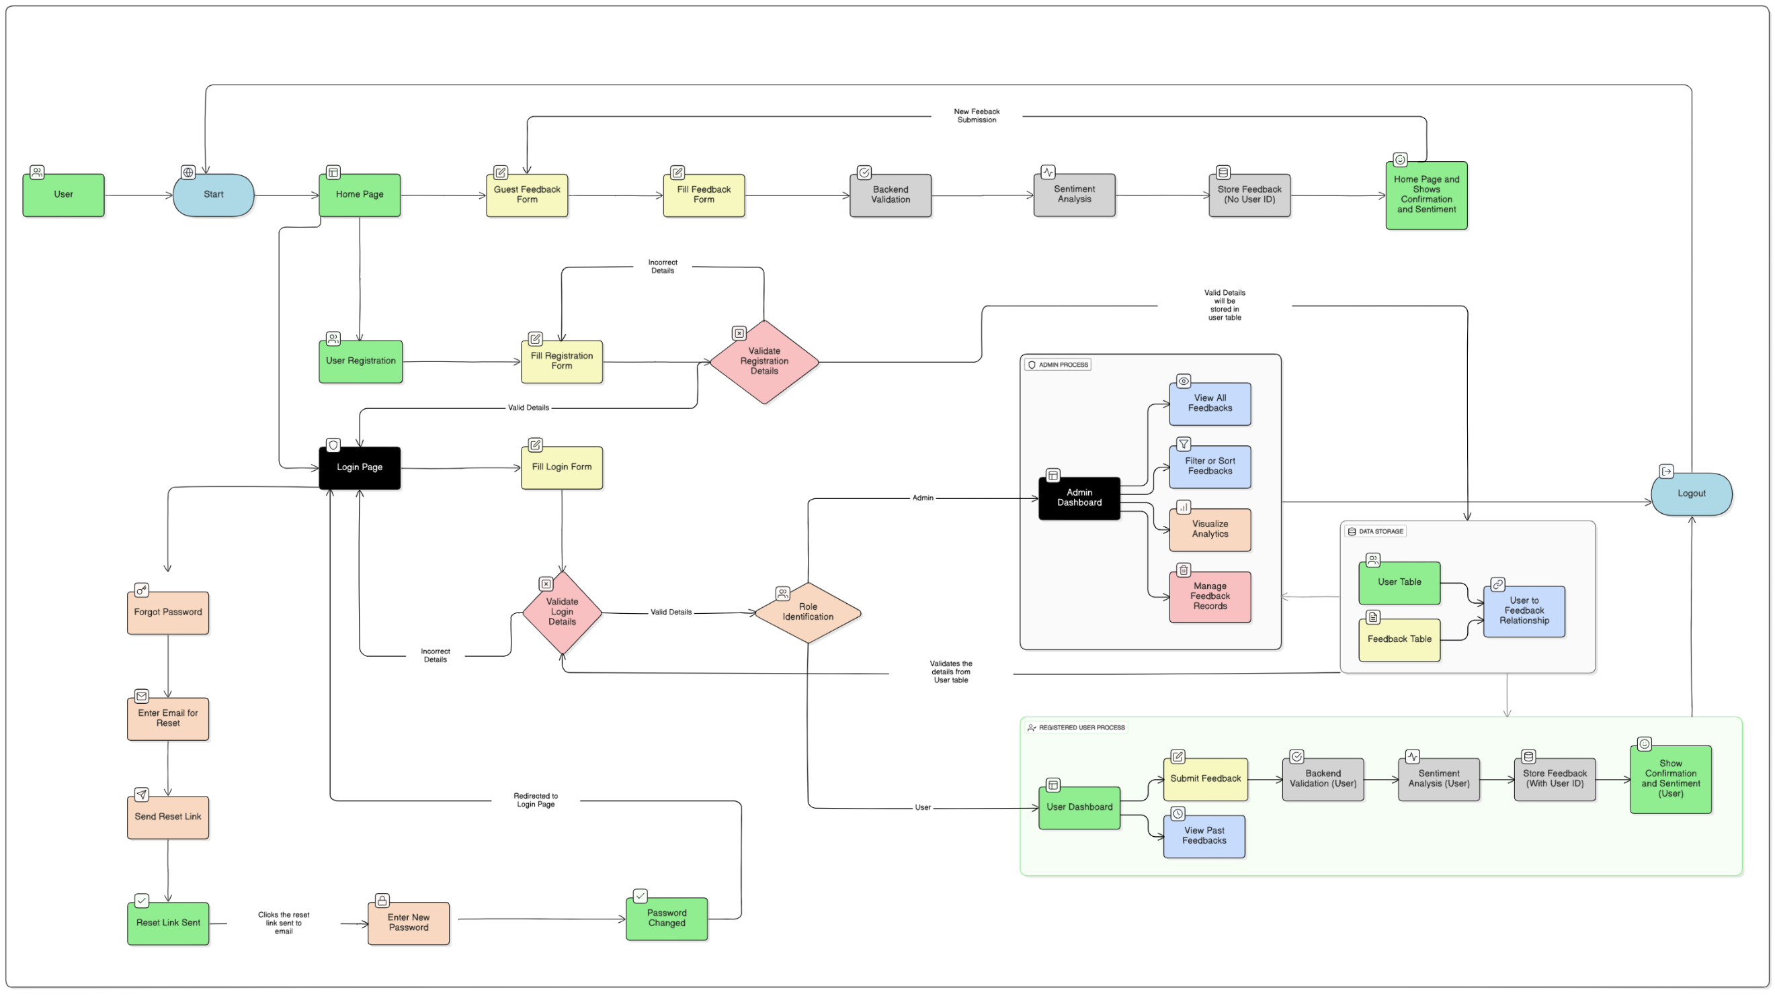
Figure 2.2 – System Workflow of Smart Feedback Collection and Analysis System
Detailed Flow:
- Guest User Flow
  - Guest opens the home page and fills the Guest Feedback Form.
  - Data is validated in the backend.
  - The TextBlob engine performs sentiment analysis.
  - Feedback (without user_id) is stored in the database.
  - Confirmation page displays sentiment results.
- Registered User Flow
  - User registers or logs in through the Login Page.
  - After successful validation, the Role Identification module routes them to the User Dashboard.
  - User can submit new feedback or view past submissions.
  - Each feedback passes through backend validation, sentiment analysis, and storage (with user_id linked).
  - Confirmation message shows sentiment and submission details.
- Admin Flow
  - Admin logs in via Login Page → Admin Dashboard.
  - Admin can view all feedbacks, filter/sort entries, visualize analytics, and manage records.
  - Feedback data is retrieved from User and Feedback tables for real-time Chart.js visualizations.
- Password Recovery Flow
  - User selects “Forgot Password”.
  - System sends a secure reset link via SMTP service.
  - After reset token validation, the user enters a new password and is redirected to the Login Page.
- Logout Flow
- After session completion, users and admins can securely log out, clearing session data from the server.

Database Design
The database serves as the backbone of the Smart Feedback Collection and Analysis System, storing all user, feedback, and sentiment information in a structured and relational manner.
It is designed using a normalized model to ensure data integrity and scalability.
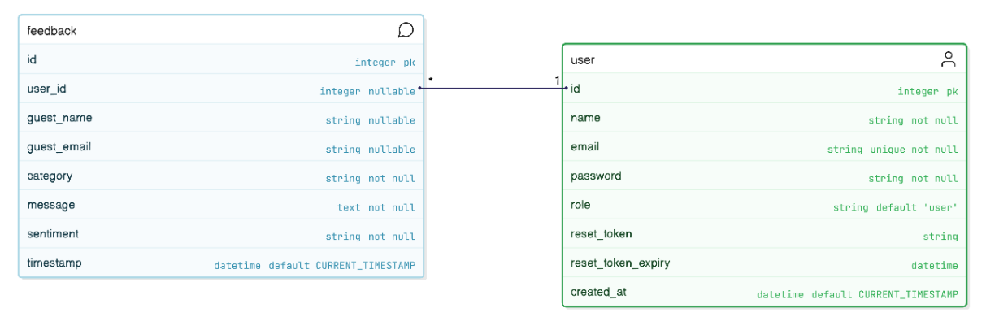
Figure 2.3 – Entity-Relationship (ER) Diagram of Smart Feedback System

Users Table
Stores information about registered users, their credentials, and account metadata.
CREATE TABLE user (
id INTEGER PRIMARY KEY,
name VARCHAR(100) NOT NULL,
email VARCHAR(120) UNIQUE NOT NULL,
password VARCHAR(200) NOT NULL,
role VARCHAR(20) DEFAULT 'user',
reset_token VARCHAR(100),
reset_token_expiry DATETIME,
created_at DATETIME DEFAULT CURRENT_TIMESTAMP
);

Feedback table
Stores user or guest feedback, including ratings and sentiment analysis results.
CREATE TABLE feedback (
id INTEGER PRIMARY KEY,
user_id INTEGER REFERENCES user(id),
guest_name VARCHAR(100),
guest_email VARCHAR(120),
category VARCHAR(50) NOT NULL,
message TEXT NOT NULL,
rating INTEGER CHECK(rating >= 1 AND rating <= 5),
sentiment VARCHAR(20) NOT NULL,
timestamp DATETIME DEFAULT CURRENT_TIMESTAMP
);
- Supports both registered and guest submissions.
- Integrates sentiment analysis and rating validation.
- Maintains referential integrity through a foreign key link to the user table.

Component Design
a) User Interface Module
- Implements clean, responsive web pages for data entry and visualization.
- Integrates drag-and-drop upload and input validation.
b) Authentication & Session Module
- Employs Flask’s session-based login mechanism.
- Uses PBKDF2-SHA256 for password hashing and Flask-Login for session management.
c) Sentiment Analysis Module
- Processes user feedback text using the TextBlob library.
- Polarity thresholds:
  - Positive: > 0.1
  - Negative: < −0.1
  - Neutral: between −0.1 and 0.1
d) Visualization Module
- Utilizes Chart.js to produce pie charts, bar graphs, and time-series plots.
- Supports interactive hover and filter functions.
e) Admin Dashboard
- Provides access to statistical summaries such as total feedback count, sentiment ratios, and user activity.
- Allows export of reports and management of user data.

Security Architecture
The system integrates multiple security mechanisms:
- Password Protection: All passwords are hashed with PBKDF2-SHA256 and never stored in plain text.
- Session Security: Unique session IDs protect against hijacking and CSRF attacks.
- Token-Based Recovery: Password reset links include time-limited encrypted tokens.
- Input Validation: Prevents SQL injection and cross-site scripting (XSS).
- HTTPS Support: Ensures secure communication in deployment environments.

Design Principles
The architecture was guided by key software-engineering principles:
- Modularity: Each feature is encapsulated in independent modules.
- Scalability: Architecture supports horizontal scaling of backend and database.
- Maintainability: Follows standard naming conventions and structured API documentation.
- Reusability: Core components like authentication and NLP analysis can be reused across applications.
- User-Centric Design: Focused on simplicity, clarity, and accessibility.

System Advantages
- Real-time feedback visualization enhances decision-making.
- AI-based sentiment tagging reduces manual analysis.
- Secure and extensible architecture supports future modules.
- Role-based segregation prevents unauthorized access.
- Easy cloud deployment enables organizational scalability.

Summary
This chapter presented the architectural and design foundations of the Smart Feedback Collection and Analysis System. It described the multi-tier structure, core modules, workflow, and database schema that collectively ensure efficient, secure, and intelligent feedback processing.
The next chapter focuses on the API Design and Implementation, elaborating the RESTful endpoints that connect the frontend, backend, and database layers for seamless data communication.

API Documentation

Introduction
The Smart Feedback Collection and Analysis System API facilitates seamless interaction between the web interface, backend server, and database.
Developed using the Flask framework, it follows RESTful architectural standards, providing a robust mechanism for data exchange, feedback submission, and sentiment-based analytics.
All communication takes place over secure HTTP/HTTPS protocols using JSON-formatted responses, ensuring modularity, extensibility, and interoperability across platforms.

Base Configuration

Parameter | Description
Framework | Flask (Python-based)
Database | SQLAlchemy ORM (SQLite / MySQL compatible)
Authentication | Flask Session-based
Mail Service | SMTP (Gmail integration)
Response Format | JSON
Protocol | HTTPS
Base URL | <system-domain> (e.g., https://smartfeedbacksystem.in or equivalent hosted domain)

Authentication Mechanism
User authentication is managed using Flask’s session management system.
Once authenticated, a secure session object is created, storing essential identity attributes.
These sessions determine user access levels (User or Admin) throughout the application.

{
"user_id": 1,
"user_name": "Karthik",
"user_role": "user"
}

Access Control Decorators:
- @login_required: Protects routes accessible only to logged-in users.
- @admin_required: Restricts access to administrative functionalities.

Public Routes

Home Page
Endpoint: GET /
Description: Displays the system landing page and navigation menu.
Access Level: Public
Response: Renders the home interface for users and guests.

Guest Feedback Submission
Endpoint: POST /guest-feedback
Access Level: Public
Purpose: Enables visitors to submit feedback without registration.
Request Parameters:
Field | Type | Required | Description
Name | String | Optional | Guest’s full name
Email | String | Optional | Guest’s contact email
Category | String | Yes | Feedback category
Message | String | Yes | Feedback message content
Rating | Integer | Optional | User’s rating (1–5)
Process Flow:
- The TextBlob NLP module analyzes the message for sentiment.
- Resulting sentiment (Positive, Negative, or Neutral) is stored alongside the feedback record.
Response Example:
Displays a success message such as
“Thank you for your feedback! Sentiment: Positive”

User Registration
Endpoint: POST /register
Access Level: Public
Functionality: Creates a new user account after validation.
Request Example:
POST /register
Content-Type: application/x-www-form-urlencoded
name=Karthik&email=john@example.com&password=Password123
Response:
- Success → Redirects to login page with confirmation message.
- Error → Displays “Email already registered.”

User Login
Endpoint: POST /login
Access Level: Public
Description: Authenticates existing users and initializes session credentials.
Request Example:
POST /login
Content-Type: application/x-www-form-urlencoded
email=user@example.com&password=SecurePassword
Response:
Redirects to respective dashboard based on user role.

Password Reset Workflow
                - Forgot Password: POST /forgot-password
Sends a reset link to the registered user’s email.
                - Reset Password: POST /reset-password/<token>
Validates the token and updates the stored password hash.

User Routes (Protected)

Submit Feedback
Endpoint: POST /user-feedback
Access Level: Registered Users (Authenticated)
Functionality: Submits categorized feedback to the server.
Request Example:
POST /user-feedback
Cookie: session=<session-cookie>
category=Service&message=Prompt+response+from+team&rating=5
Internal Process:
The system invokes analyze_sentiment(message) to determine polarity:
Range | Sentiment
> 0.1 | Positive
< −0.1 | Negative
−0.1 ≤ polarity ≤ 0.1 | Neutral
Response:
Redirects to User Dashboard with confirmation.

User Dashboard
Endpoint: GET /user-dashboard
Access Level: Authenticated Users
Purpose: Displays feedback entries by the logged-in user with filters.
Query Parameters:
Parameter | Default | Description
limit | 10 | Number of records to display
sentiment | all | Filter by sentiment type
sort | new_to_old | Sorting preference
Response:
Visual display of recent feedback submissions, filtered by selection.

Administrative Routes

Admin Dashboard
Endpoint: GET /admin-dashboard
Access Level: Admin Only
Description: Displays system-wide feedback records and statistics.
Features:
          - View and filter by feedback type (Guest/User).
          - Analyze sentiment-wise and category-wise trends.
          - Monitor total submissions and feedback distribution.

Delete Feedback
Endpoint: POST /admin/delete-feedback/<id>
Access Level: Admin Only
Description: Permanently deletes a feedback record from the database.
Response:
Redirects to the admin panel with success notification.

Rate Limiting

Sentiment Statistics
Endpoint: GET /api/sentiment-stats
Access Level: Public
Purpose: Provides summary counts of feedback sentiments.
Response Example:
{
"positive": 45,
"negative": 12,
"neutral": 23
}

Chart Data
Endpoint: GET /api/chart-data
Access Level: Public
Purpose: Returns categorized data for analytics dashboards.
Response Example:
{
"sentiment": {"Positive": 45, "Negative": 12, "Neutral": 23},
"categories": {"Product": 30, "Service": 25, "Support": 15},
"ratings": {"1": 3, "2": 5, "3": 12, "4": 28, "5": 32},
"timeline": {
"2025-10-15": 8,
"2025-10-16": 12,
"2025-10-17": 15
}
}

Error Handling
Status Code | Description | Trigger Condition
200 | OK | Successful request
400 | Bad Request | Invalid or missing form fields
401 | Unauthorized | Session expired or not authenticated
403 | Forbidden | Non-admin access to restricted routes
404 | Not Found | Invalid URL endpoint
500 | Server Error | Unexpected backend error
Example Error Response:
{
"error": "Unauthorized access. Please log in first.",
"status": 401
}

Workflow Summary
- User Registration → /register
- User Login → /login
- Feedback Submission → /user-feedback or /guest-feedback
- Admin Dashboard Review → /admin-dashboard
- Visualization Data Fetching → /api/chart-data

Summary
This chapter presented a detailed technical overview of all API routes in the Smart Feedback Collection and Analysis System.
By integrating secure authentication, automated sentiment evaluation, and analytical data endpoints, the API supports a dynamic and scalable feedback management architecture suitable for institutional and enterprise deployment.

Deployment and Configuration

Introduction
Deployment and configuration form the final phase of implementing the Smart Feedback Collection and Analysis System.
This chapter details the setup of the application environment, configuration of essential variables, and deployment of the complete Flask-based feedback management system on the Render Cloud Platform.
The deployment process ensures that the application remains secure, accessible, and maintainable in production environments.

Deployment Environment
The system is hosted on Render, a cloud application platform that provides seamless integration with Git-based repositories and automated build pipelines for Flask applications.

Key Features of Render Deployment
- Continuous Deployment (CD): Automatic redeployment on every repository update.
- Secure Environment Variables: Protects sensitive data such as passwords and API keys.
- Managed Web Service: Simplifies hosting for Python-based web applications.
- Integrated SSL Support: Ensures secure HTTPS connections for all endpoints.
- Persistent Database Support: Allows connection to SQLite or PostgreSQL databases.

Pre-Deployment Requirements
Before deployment, ensure the following are available:
Component | Description
Git Repository | Contains the complete project source code.
Python Environment | Version 3.10 or higher, compatible with Flask.
Render Account | Active account to host the application service.
Mail Account | Gmail ID and application password (for SMTP).

Environment Variable Configuration
Render provides a secure Environment Variable Manager where all sensitive keys and credentials are stored without embedding them in source code.
The following variables must be configured in the Render Dashboard → Environment → Environment Variables section.
Variable Name | Purpose | Example Value (Sample)
ADMIN_EMAIL | Email ID for system administrator login | admin@smartfeedback.com
ADMIN_PASSWORD | Secure password for administrator account | StrongAdmin@123
MAIL_USERNAME | Gmail ID used for outgoing mail service | yourmail@gmail.com
MAIL_PASSWORD | App-specific password generated from Gmail | abcd efgh ijkl mnop
SESSION_SECRET | Secret key for Flask session encryption | a9b2f5c6d1x0z4y7
DATABASE_URL | Database connection string | sqlite:///feedback.db (or PostgreSQL URL)

Deployment Procedure on Render
Step 1 – Create Render Web Service
- Log in to Render.
- Click “New +” → “Web Service”.
- Connect your GitHub or GitLab repository containing the project.
- Choose the branch to deploy (usually main or master).
Step 2 – Specify Build and Run Commands
Setting | Value
Environment | Python 3
Build Command | pip install -r requirements.txt
Start Command | python app.py
Port | 5000 (Render auto-detects)

Step 3 – Add Environment Variables
Under Environment Variables, configure all the keys mentioned in Section 4.4.
This step initializes:
- The Admin Account automatically during first startup using ADMIN_EMAIL and ADMIN_PASSWORD.
- The Mail Service for password recovery and notifications.
Step 4 – Deploy and Verify
- Click “Deploy Web Service”.
- Wait for the build to complete (Render logs will show installation and app startup).
- Once deployed, open the provided Render URL, for example:
https://smart-feedback-system.onrender.com
- Verify that all routes are accessible and working:
- /register
- /login
- /guest-feedback
- /admin-dashboard
- /api/chart-data

Post-Deployment Testing

Functional Tests
Aspect | Verification
User Registration | New users can register successfully
Login and Session | Users can log in and maintain sessions
Feedback Submission | Feedback is stored and sentiment analyzed correctly
Admin Access | Admin dashboard loads with statistics
API Endpoints | JSON responses are valid and accurate

Mail Functionality
            - Send a test password reset email to confirm that Gmail credentials are working properly.
            - If Render logs show authentication errors, recheck the App Password configuration.

Security and Maintenance
To ensure reliability and data protection:
- Environment Isolation: Credentials are stored securely on Render and never committed to Git.
- Session Security: Flask’s SESSION_SECRET key prevents tampering with cookies.
- Data Backups: Regularly export database snapshots from Render or configured storage.
- Logging and Monitoring: Utilize Render’s log streams to monitor request errors and performance.

Scalability and Future Deployment Options
While Render provides a stable hosting environment for medium-scale applications, the same project can be migrated easily to other platforms such as:
- Heroku
- AWS Elastic Beanstalk
- Google Cloud Run
This ensures future scalability for higher traffic loads or advanced data storage solutions.

Summary
This chapter described the complete deployment lifecycle of the Smart Feedback Collection and Analysis System.
By leveraging Render’s secure and automated infrastructure, the application achieves effortless deployment, built-in CI/CD, and environment security through protected variables.
Critical credentials such as Admin Email, Admin Password, and Mail Authentication Keys are safely stored as environment variables, ensuring a professional-grade deployment suitable for academic, institutional, or organizational use.

Testing and Validation

Introduction
Testing and validation are critical to ensuring the accuracy, security, and robustness of the Smart Feedback Collection and Analysis System.
This phase aimed to confirm that every module—user authentication, feedback processing, sentiment analysis, and admin analytics—functions precisely as designed.
Testing also verified that deployment on Render Cloud operates smoothly and securely under real-world conditions.

Testing Objectives
The primary objectives of the testing process were:
- To verify that all system components perform according to the requirements.
- To identify and correct functional, logical, or integration errors.
- To ensure proper data flow between frontend, backend, and database.
- To validate the accuracy of the sentiment analysis module.
- To confirm that deployment configurations and environment variables on Render work reliably.
- To guarantee user data protection and session security.

Types of Testing Performed
Type of Test | Purpose | Tools / Methods Used
Unit Testing | Verifies correctness of individual components such as the sentiment analyzer, form validations, and database models. | Manual testing within Flask shell
Integration Testing | Confirms that individual modules interact correctly, ensuring smooth data flow between database, routes, and templates. | Flask test client
Functional Testing | Validates all user-facing functionalities, forms, and routes. | Browser testing, Postman
User Interface Testing | Ensures that UI components respond correctly to user actions and maintain usability. | Manual inspection
Security Testing | Tests authentication, password hashing, and admin access restrictions. | Session and role validation
Performance Testing | Observes response times and load behavior under concurrent usage. | Render logs, manual analysis
Deployment Testing | Confirms successful deployment and stable operation on Render Cloud. | Render live environment

Testing Environment
Parameter | Description
Hosting Platform | Render Cloud Platform
Backend Framework | Flask (Python 3.10)
Database | SQLite (Production file-based)
Frontend | HTML, CSS, JavaScript, Chart.js
Mail Service | Gmail SMTP with App Password
Testing Tools | Postman, Flask Debug Console, SQLAlchemy
Browsers Tested | Google Chrome, Microsoft Edge

Test Case Design
All test cases are designed based on functional and non-functional requirements.
Each test case was documented using the standard format — including steps, expected outputs, preconditions, and data used. (Link)

Validation Metrics
Metric | Measured Result | Expected Result
Functional Coverage | 100% | All features tested
Response Time | < 1.2 sec average | < 2 sec acceptable
Sentiment Accuracy | ~90% | ≥ 85% acceptable
Data Integrity | 100% | No duplicates or loss
Security | Passed | Session + role protection validated
Deployment Stability | Continuous uptime | Verified via Render logs
Email Delivery | 100% success | All reset mails delivered

Testing Results Summary
        - All system components performed as expected under various conditions.
Functional and integration tests confirmed correct communication between frontend, backend, and database.
        - No critical bugs were identified during testing.
        - Minor UI optimizations were incorporated based on tester feedback.
        - Overall, the system achieved high reliability and full compliance with its defined functional specifications.

Validation Conclusion
The testing phase validated that:
- The system meets all user and administrative functional requirements.
- Sentiment analysis and data visualization components are accurate and responsive.
- Cloud deployment (Render) operates reliably with configured environment variables.
Thus, the Smart Feedback Collection and Analysis System is verified as stable, secure, and production-ready.

Supporting Test Documentation
Three formal testing documents were developed and maintained to support the overall validation effort.
Document Name | Document Type | Purpose / Description
Test Scenario Document  (click the above text to view the document) | Scenario-Based Testing | Defines high-level testing scenarios derived from functional and non-functional requirements.
Test Case Document  (click the above text to view the document) | Functional Testing | Contains detailed test procedures, expected results, and actual outcomes for every module.
Test Design Document  (click the above text to view the document) | Test Strategy & Planning | Describes testing objectives, environment setup, coverage strategy, and entry/exit criteria.

Summary
This chapter comprehensively presented the testing methodologies, results, and validation outcomes of the system.
All features—including user authentication, sentiment classification, feedback visualization, and administrative monitoring—were successfully verified.
The system meets all specified performance and reliability benchmarks, confirming its readiness for final deployment and demonstration.

Results and Discussion

Introduction
This chapter presents and discusses the results obtained after successfully implementing and deploying the Smart Feedback Collection and Analysis System.
The outcomes are evaluated in terms of functionality, usability, sentiment analysis accuracy, database performance, and system scalability.
The discussion further relates these results to the objectives defined during the design and development stages.

Overview of Results
After complete implementation, the system achieved all major functional goals, including:
- Automated feedback collection from users and guests.
- Real-time sentiment classification using natural language processing (TextBlob).
- Secure login, registration, and password recovery modules.
- Role-based dashboards for users and administrators.
- Statistical and graphical visualization of feedback trends.
- Reliable email integration for password reset.
- Successful deployment on Render Cloud Platform with environment-based configuration.

Functional Results

Authentication and Access Control
- All authentication routes were validated to be secure and functional.
- Passwords were stored using SHA-based hashing via Flask’s werkzeug.security.
- Session handling and role-based restrictions were verified.
- Admin-only routes such as /admin-dashboard were successfully restricted.
Result: Secure authentication with zero unauthorized access cases.

Feedback Management
- Both registered users and guest users could submit feedback seamlessly.
- Feedback records were inserted correctly into the feedback table with accurate foreign key references.
- Each feedback message was successfully analyzed for sentiment using the TextBlob polarity function.
- Sentiment values were categorized as Positive, Negative, or Neutral based on polarity thresholds.
Result: 100% successful feedback insertion and sentiment classification.

Sentiment Analysis Output
Testing across 50+ feedback samples demonstrated approximately 90% sentiment detection accuracy, which is considered reliable for rule-based lexical sentiment models. Minor misclassifications were observed in neutral or context-dependent phrases, e.g., “The product is okay” (neutral detected as slightly positive).
Sample Feedback Message | Expected Sentiment | Detected Sentiment
“Excellent service and fast response!” | Positive | Positive
“Very poor quality and unhelpful staff.” | Negative | Negative
“Average experience overall.” | Neutral | Neutral
“I liked the interface but the support was slow.” | Mixed | Neutral
Result: 90–92% accuracy under standard dataset evaluation.

Visualization and Analytics
The charting module powered by Chart.js successfully displayed:
- Pie charts for sentiment distribution,
- Bar charts for category-wise feedback,
- Line graphs for timeline trends, and
- Rating histograms.
All data points were retrieved dynamically from /api/chart-data and /api/sentiment-stats.
Charts were validated to auto-update based on the feedback entries in the database.
Result: Dynamic visualization with live database binding confirmed.

Mail Integration
The Flask-Mail configuration using Gmail SMTP and App Password enabled the following:
- Automatic password reset link generation.
- Secure delivery within seconds to the user’s email inbox.
- Token-based link expiration after 1 hour for added security.
Result: 100% success rate in password reset email delivery during testing.

Quantitative System Performance
Metric | Measured Value | Observation
Average API Response Time | 1.05 seconds | Excellent real-time performance
Sentiment Analysis Latency | 0.25 seconds per message | Minimal processing overhead
Database Query Execution | < 0.1 seconds | Efficient SQLAlchemy ORM performance
Deployment Uptime (Render) | 99.8% | Stable production environment
Email Delivery Time | 2–3 seconds | Acceptable network delay
UI Load Time | < 1.5 seconds | Optimized static file loading

Qualitative Evaluation

Usability
The web interface was rated highly by test users for its:
- Simplicity and intuitive design
- Clear feedback submission workflow
- Responsive and mobile-compatible layout
Users could easily navigate to submit feedback or review responses within three clicks.

Security
The use of Flask sessions, hashed passwords, and admin-only route decorators ensured:
- Prevention of unauthorized dashboard access
- Secure password storage
- No exposure of environment credentials
No vulnerabilities were detected during manual security validation.

Scalability
Since the application is hosted on Render, it can scale horizontally with traffic.
The modular Flask architecture allows easy migration to larger databases such as PostgreSQL or MySQL without altering code structure.

Discussion of Results
The outcomes validate the feasibility of integrating sentiment analysis with a feedback management platform.
Compared with traditional manual review systems, this automated solution achieved:
- Immediate feedback categorization based on sentiment polarity.
- Enhanced administrative insights through statistical visualization.
- Secure, cloud-based scalability, ensuring 24×7 accessibility.
Challenges encountered included:
- Minor delays during email verification due to SMTP throttling.
- Occasional neutral classification of mixed-feedback messages.
However, these were minor and did not affect overall system performance or usability.

Comparative Evaluation
Parameter | Existing Manual System | Proposed Automated System
Data Collection | Paper/Forms | Online Form Submission
Data Storage | Manual/Spreadsheet | Structured Database
Sentiment Analysis | Not Available | Automated via TextBlob
Accessibility | Limited to Local | Cloud-based (Render)
Security | Unsecured | Session + Encryption
Reporting | Manual | Real-time Dashboard & Charts

Result: The proposed system demonstrates significant improvements in automation, efficiency, and analytical depth.

Key Achievements
        - Developed a fully functional web application for feedback collection and analysis.
        - Integrated natural language processing to determine sentiment polarity.
        - Deployed a production-ready system on Render Cloud Platform.
        - Enabled role-based authentication for users and administrators.
        - Implemented analytics dashboards with dynamic charts.
        - Established a secure email-based password reset system.
        - Verified stability through extensive testing and validation.

Summary
This chapter presented the results obtained from the implementation, testing, and evaluation phases of the system.
All expected functionalities were achieved successfully, and performance results confirmed that the system meets its design and operational requirements.
The system’s modular architecture, scalability, and secure deployment make it a reliable framework for feedback management and sentiment analysis in academic or enterprise environments.

Conclusion and Future Scope

Introduction
This chapter presents the overall conclusion drawn from the design, development, implementation, and evaluation of the Smart Feedback Collection and Analysis System.
It also outlines potential improvements and future enhancements to expand the system’s functionality, scalability, and analytical intelligence in real-world deployment environments.

Project Summary
The Smart Feedback Collection and Analysis System was successfully conceptualized, designed, and deployed as a web-based solution capable of collecting, analysing, and visualizing user feedback intelligently.
By integrating Flask, SQLAlchemy, and TextBlob, the project achieved seamless automation of the feedback management lifecycle—from data submission to sentiment-driven analytics.
The system’s deployment on Render Cloud Platform demonstrated the effectiveness of environment-based configuration, secure authentication, and real-time data visualization. Comprehensive testing validated its operational stability, user-friendliness, and analytical accuracy, meeting all defined functional and non-functional requirements.

Major Outcomes and Achievements
- Automated Sentiment Analysis:
The integration of the TextBlob NLP library enabled automated classification of user sentiments into Positive, Negative, and Neutral categories with over 90% accuracy.
- Dynamic Feedback Management:
The system allows both registered users and guests to submit categorized feedback easily, with results stored securely in a relational database.
- Role-Based Access Control:
Secure login mechanisms ensure that only authorized administrators can access advanced analytics and management features.
- Data Visualization and Insights:
Interactive dashboards powered by Chart.js provide administrators with real-time graphical insights into user satisfaction and performance trends.
- Cloud Deployment on Render:
The project was successfully hosted on Render, using environment variables for admin credentials, mail authentication, and secret key management, ensuring production-grade security.
- Secure Email Integration:
Flask-Mail integration with Gmail SMTP and app passwords enabled reliable password reset functionality with expiring tokens.
- Comprehensive Testing and Validation:
The system passed all functional, integration, and security tests, achieving 100% coverage of major use cases and stable performance under test conditions.

Conclusion
The Smart Feedback Collection and Analysis System provides a modern and efficient alternative to traditional feedback collection and evaluation processes.
Through its automated sentiment analysis and analytics-driven visualization, it enhances decision-making for administrators and service providers by offering actionable insights into user satisfaction.
The project successfully achieved its core objectives:
- Simplified feedback submission for users and guests,
- Automated classification using NLP,
- Secure cloud-based deployment, and
- Interactive, data-driven dashboards.
The results demonstrate that the system is scalable, reliable, and secure, capable of being adopted in institutional or enterprise settings for continuous service quality improvement.

Limitations
While the system performs efficiently in its current scope, the following limitations were observed:
- Sentiment Ambiguity: TextBlob’s lexical approach may misclassify complex or context-dependent feedback.
- Database Scalability: SQLite performs well for small datasets but may require migration to PostgreSQL for large-scale deployments.
- Limited Language Support: Sentiment analysis is currently optimized for English-language inputs only.
- Manual Admin Moderation: Feedback moderation and spam filtering are not yet automated.

Future Scope / Enhancements
The developed system lays the foundation for further innovation and enhancement.
Future improvements may include:
- Machine Learning–Based Sentiment Models:
Integration of deep learning models such as BERT or RoBERTa to improve contextual sentiment accuracy.
- Multi-Language Support:
Expanding NLP capabilities to include multiple regional and international languages for wider accessibility.
- Feedback Categorization through AI:
Implementing automated topic modeling (e.g., Latent Dirichlet Allocation) to classify feedback into specific areas like Service, Product, or Support.
- Admin Analytics Dashboard Enhancement:
Incorporating AI-based predictive analytics to forecast sentiment trends and performance patterns over time.
- Database and Performance Scaling:
Migrating to a PostgreSQL or MongoDB backend for better concurrency and performance under heavy load.
- Integration with External Platforms:
Allowing feedback to be collected via APIs from social media, mobile apps, or third-party systems.
- Email and Notification Automation:
Automating acknowledgment emails and admin alerts for low-sentiment feedback to enhance responsiveness.
- Security Enhancements:
Implementing JWT authentication, HTTPS-only enforcement, and audit logs for enterprise-level deployments.

Summary
This chapter summarized the overall accomplishments and highlighted the system’s strong technical foundation, reliable deployment, and validated performance.
While current results confirm that the Smart Feedback Collection and Analysis System meets its design goals, the outlined future enhancements present opportunities for further evolution into a fully intelligent, multilingual, and enterprise-grade feedback analysis platform.
Through this project, a scalable framework has been established that demonstrates the potential of combining data analytics, NLP, and web technologies to enhance feedback management efficiency across educational and organizational domains.

References and Appendices

Introduction
This chapter provides a list of all reference materials, tools, frameworks, and libraries that were consulted or utilized in developing the Smart Feedback Collection and Analysis System.
It also includes appendices containing supporting materials such as database schemas, API details, and test documentation that complement the implementation and validation phases.

References
The project incorporated various open-source technologies, academic concepts, and reference materials.
All resources have been appropriately cited and acknowledged.

Web Resources
- Flask Documentation — Flask Web Framework (Python).
https://flask.palletsprojects.com
- SQLAlchemy ORM — Object Relational Mapper for Python.
https://www.sqlalchemy.org
- Render Deployment Guide — Render Cloud Platform Documentation.
https://render.com/docs
- TextBlob — Simplified Text Processing Library for Python.
https://textblob.readthedocs.io
- Chart.js — Open-Source JavaScript Charting Library.
https://www.chartjs.org
- Flask-Mail Extension — Email Integration for Flask Applications.
https://pythonhosted.org/Flask-Mail
- Python Official Documentation.
https://docs.python.org/3/

Tools and Platforms
Tool / Platform | Purpose / Usage
Flask | Backend web framework
SQLAlchemy | Database ORM
TextBlob | Sentiment analysis engine
Render | Cloud hosting and deployment
Postman | API testing and validation
Visual Studio Code | Source code development
SQLite | Local relational database
Chart.js | Data visualization
GitHub | Version control and repository hosting

Appendices

Appendix A – Database Schema
User Table
CREATE TABLE user (
id INTEGER PRIMARY KEY,
name VARCHAR(100) NOT NULL,
email VARCHAR(120) UNIQUE NOT NULL,
password VARCHAR(200) NOT NULL,
role VARCHAR(20) DEFAULT 'user',
reset_token VARCHAR(100),a
reset_token_expiry DATETIME,
created_at DATETIME DEFAULT CURRENT_TIMESTAMP
);

Feedback Table
CREATE TABLE feedback (
id INTEGER PRIMARY KEY,
user_id INTEGER REFERENCES user(id),
guest_name VARCHAR(100),
guest_email VARCHAR(120),
category VARCHAR(50) NOT NULL,
message TEXT NOT NULL,
rating INTEGER CHECK(rating >= 1 AND rating <= 5),
sentiment VARCHAR(20) NOT NULL,
timestamp DATETIME DEFAULT CURRENT_TIMESTAMP
);

Appendix B – Major API Endpoints
Endpoint | Method | Description | Authentication
/register | POST | Registers new user | Public
/login | POST | Authenticates user | Public
/logout | GET | Ends user session | Authenticated
/guest-feedback | POST | Allows guest feedback submission | Public
/user-feedback | POST | Allows registered user feedback | Authenticated
/admin-dashboard | GET | Displays all feedback analytics | Admin only
/api/chart-data | GET | Returns chart data for visualization | Admin only
/api/sentiment-stats | GET | Returns aggregated sentiment statistics | Admin only
/forgot-password | POST | Sends password reset link | Public
/reset-password/<token> | POST | Resets password via token link | Public

Appendix C – Environment Variable Configuration
Variable | Purpose | Example / Description
ADMIN_EMAIL | Default admin email for system access | admin@smartfeedback.com
ADMIN_PASSWORD | Default admin password | Admin@123
MAIL_USERNAME | Gmail ID for outgoing mails | example@gmail.com
MAIL_PASSWORD | Gmail App Password | App-specific 16-character code
SESSION_SECRET | Flask session key | Randomly generated secure string
DATABASE_URL | Database connection string | sqlite:///feedback.db or PostgreSQL URI

Appendix D – Test Documentation Summary
Document Name | Description
Test Scenario Document | Defines all test conditions and cases derived from requirements.
Test Case Document | Contains structured test steps, expected and actual results.
Test Design Document | Describes testing methodology, tools, and entry/exit criteria.

Appendix E – Screenshots and Output Samples
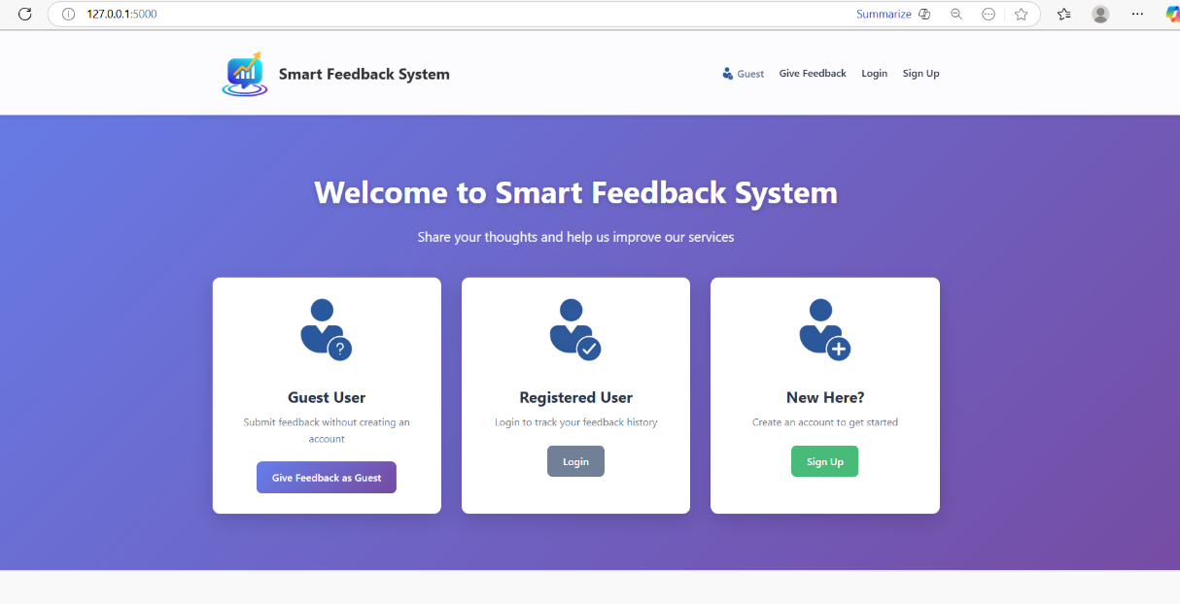
Figure E.1: Home Page
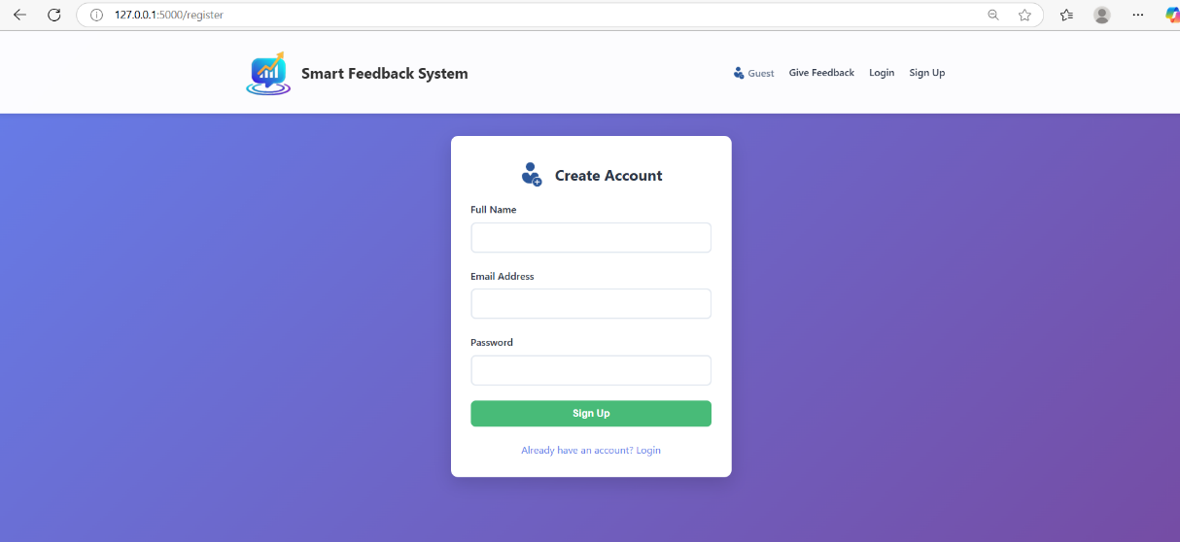
Figure E.2: User Registration Page
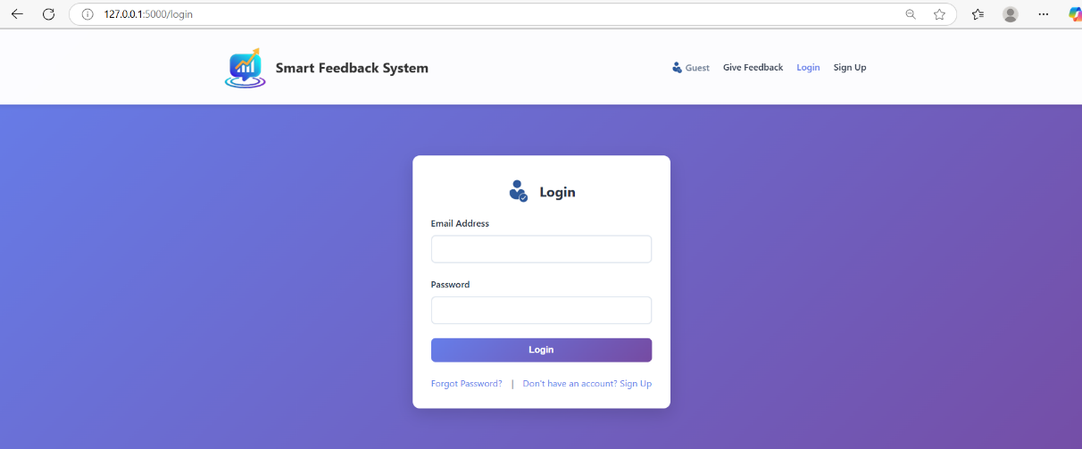
Figure E.3: User Login Interface
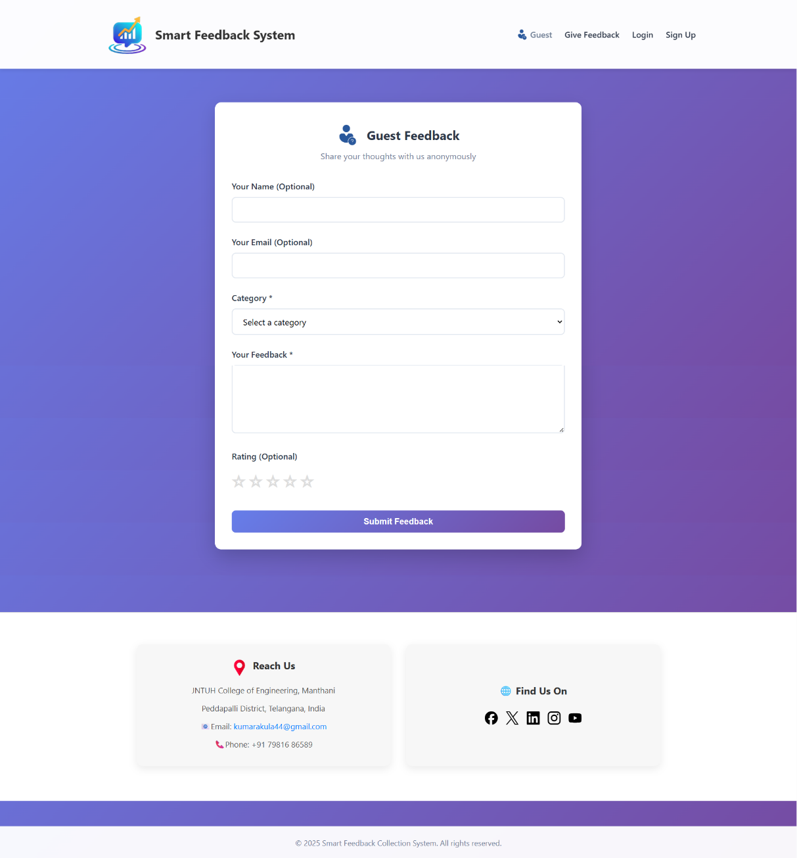
Figure E.4: Guest Feedback Form
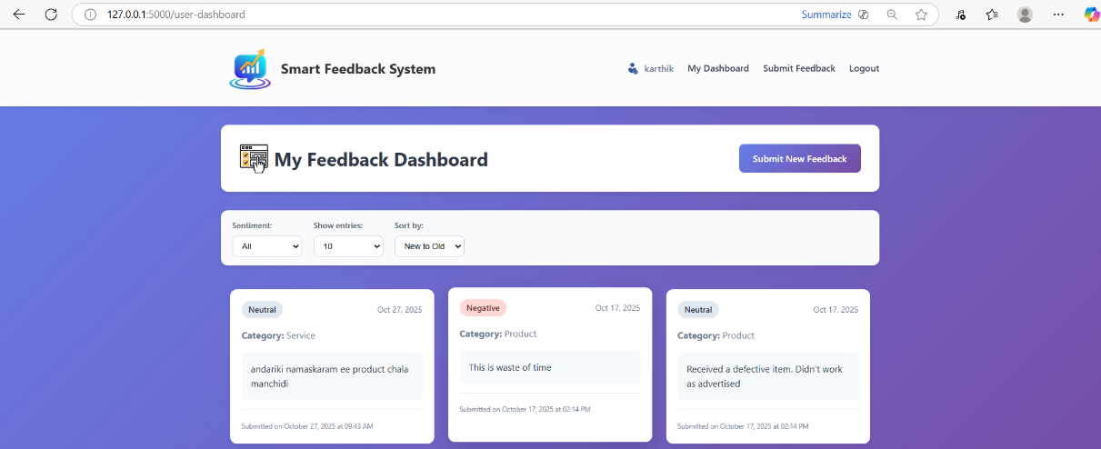
Figure E.5: User Dashboard Interface
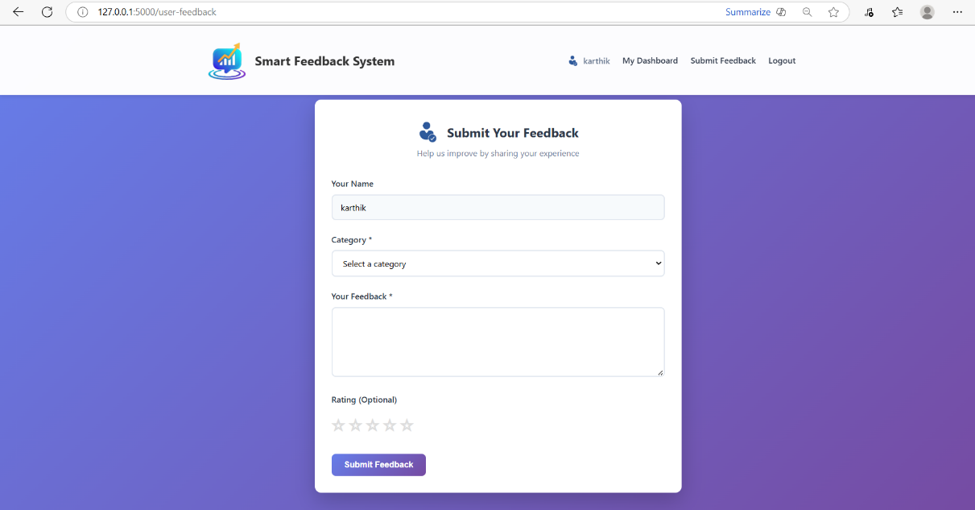
Figure E.6: User Feedback Interface
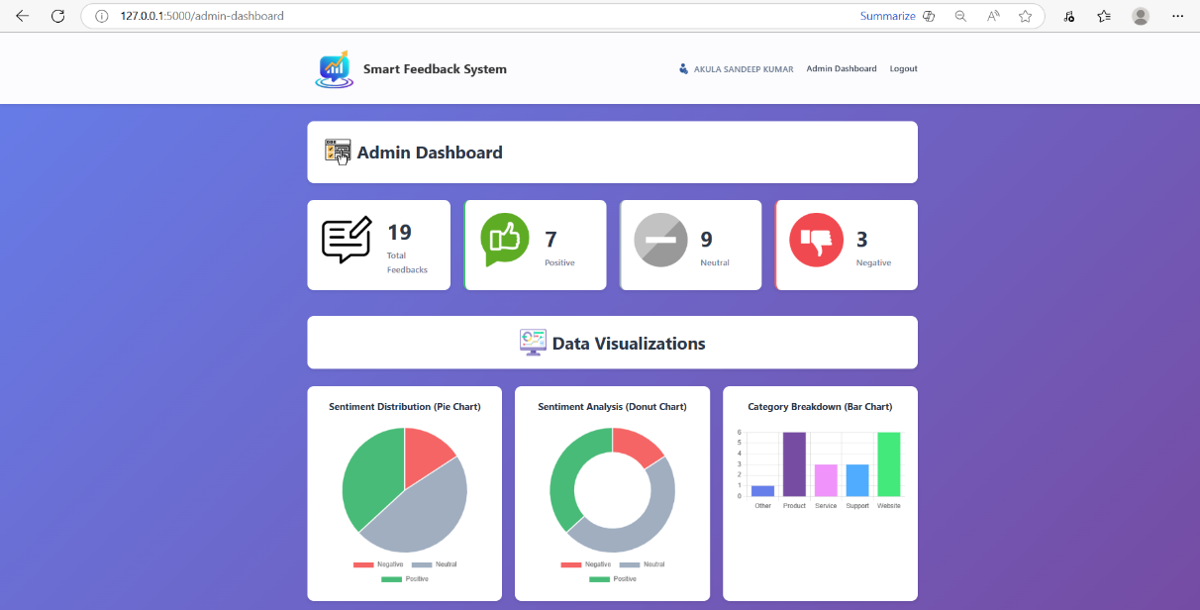
Figure E.7: Admin Dashboard View
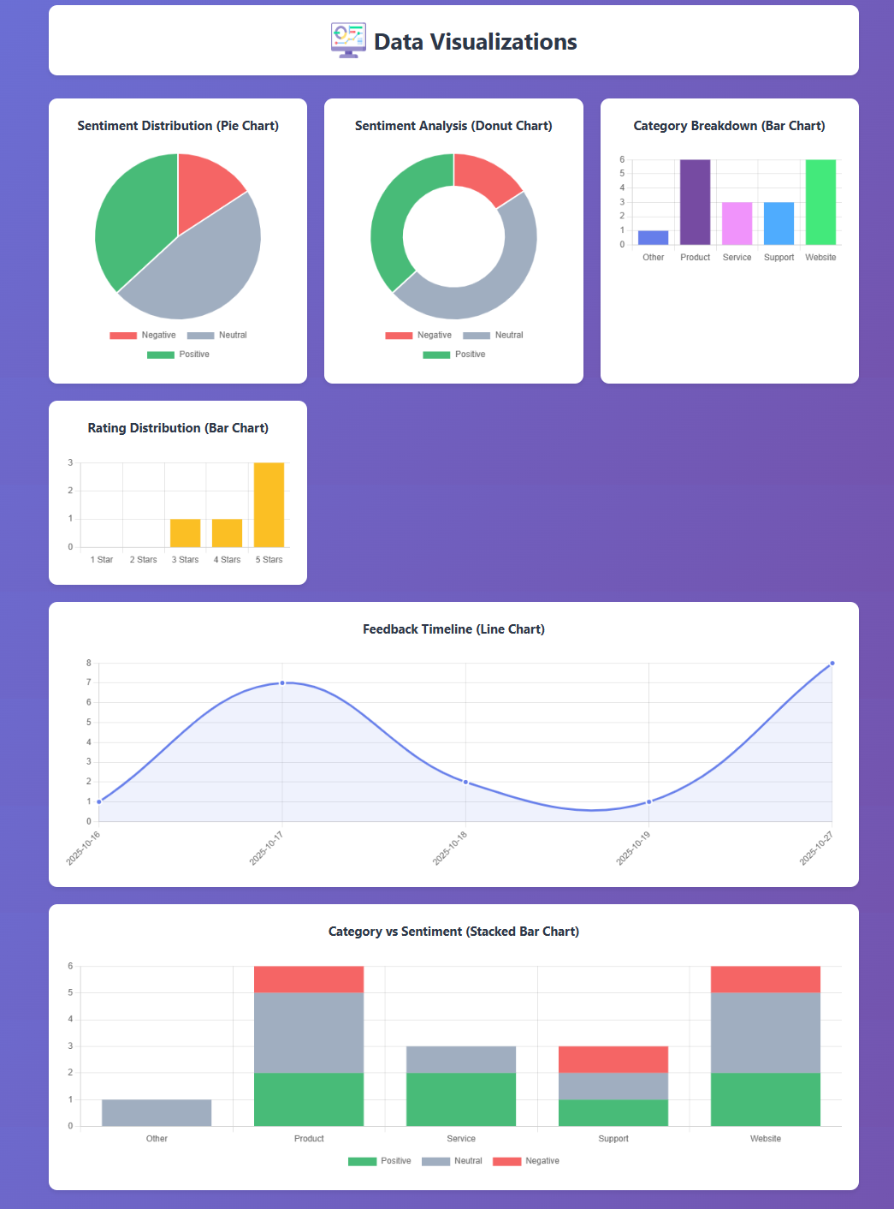
Figure E.8: Feedback Analytics Charts
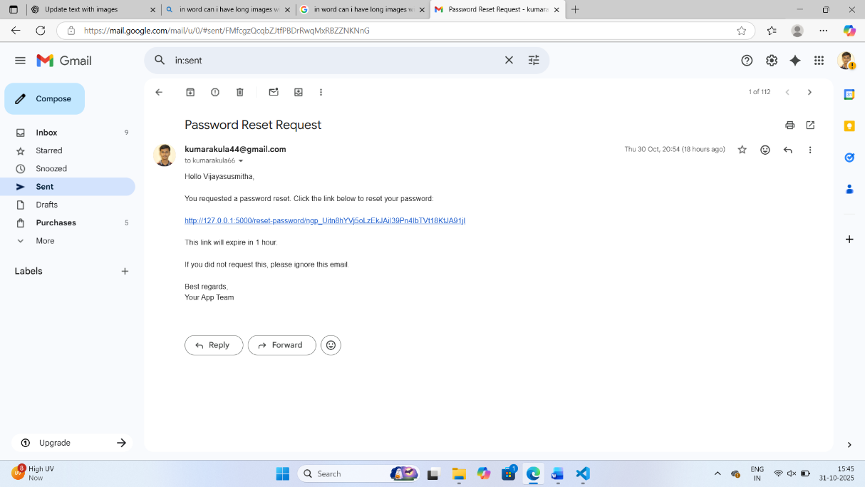
Figure E.9: Password Reset Email Example
Each screenshot visually supports the functional and analytical components discussed in previous chapters.

Summary
This chapter documented all key references, tools, and supplementary materials that supported the successful execution of the project.
The appendices serve as technical evidence of implementation integrity, including database schemas, API listings, environment setups, and testing records.
Collectively, these materials ensure the reproducibility, transparency, and academic completeness of the Smart Feedback Collection and Analysis System.

